Analysis of Endothelial Mitochondrial Dysfunction Due to Uremic and Indoxyl Sulfate Toxicity

Simran M. Karim, *Department of Biomedical Engineering, University of Utah, Salt Lake City UT*

***Abstract— Objective:* Understanding the leading cause of cardiovascular disease (CVD) in chronic kidney disease (CKD) patients is imperative for the proper treatment of CKD patients. In this paper, we hypothesize that abnormal amounts of uremic metabolites in the body results in mitochondrial dysfunction which in turn induces CVD in CKD patients. For our study, we have outlined proposed methods to identify the impacts of uremic metabolites and indoxyl sulfate on endothelial mitochondria. A comprehensive assessment of two mitochondrial energy metabolism processes will be examined through oxygen consumption rate (OCR) and extracellular acidification rate (ECAR), and an assessment of mitochondrial reactive oxygen species (ROS) production will be examined. The OCR assessment will give us details on levels of oxygen consumption by mitochondria, primarily concerning ATP-linked respiration. Based on research, we expect lower consumption of oxygen due to uremic toxicity, indicating mitochondrial impairment. ECAR assessment will be used to determine the acidity level depending on the free protons released in the mitochondrial extracellular space during glycolysis, where lower acidity indicates mitochondrial inefficiency. Our third method includes a MitoSOX assay using the fluorescence ELISA reader to measure the superoxide/ROS levels in mitochondria, where high fluorescence intensity implies high ROS levels, indicating high mitochondria dysfunction. Currently there is no research in literature that has assessed the OCR, ECAR and ROS levels due to uremic toxicity in endothelial mitochondria of CVD in CKD patients. Therefore, we aim to understand the association of CVD and mitochondria dysfunction in CKD patients through this study.**

**Index Terms – uremic metabolites; indoxyl sulfate; mitochondrial dysfunction; Seahorse XF; MitoSOX**

1. INTRODUCTION

C

HRONIC kidney disease (CKD) is a condition characterized by the gradual loss of kidney function over a period of time, and it affects approximately 37 million people in the US [1]. CKD progresses through multiple stages of kidney damage leading up to end-stage kidney disease (ESKD), where patients suffer from complete loss of kidney function [2]. CKD patients’ need proper treatment to mitigate for the reduced or complete loss of kidney functions [1]. However, patients are unable to receive proper treatment due to CKD-induced health complications during their early stages of CKD [2]. One of the primary complications include cardiovascular disease (CVD) [2] The resulting CVD prevents patients from receiving proper care that causes patients to more often encounter premature death [2]. CVD observed in CKD patients includes a wide spectrum of complications, such as arrhythmias, ischemic heart disease, peripheral vascular disease and congestive heart failure [2]. Recent studies have indicated that CKD is considered to be the equivalent of coronary artery disease, implicating that patients are prone to CVD-related deaths as early as the initial stages of CKD [2]. Additionally,

experiments carried to understand the cardiovascular activities in CKD patients have shown an inverse increase in heart rate with estimated glomerular filtration rate, implicating an increase in pathogenic cardiovascular events with reduced kidney function [2]. In fact, according to The United States Renal Data System report in 2014, the occurrence of CVD is doubled in CKD patients (69.8% vs 34.8%) [2]. Despite having vast information about CKD-induced CVD in patients, the molecular mechanisms that results in CVD formation in patients are not yet well understood. Therefore, it is imperative to investigate the underlying causes of CVD in patients suffering from CKD.

Interestingly, research has shown that CKD patients have high oxidative stress in their system [2,3]. Research has shown that high oxidative stress can cause increased cardiac damage, such as apoptosis, hypertrophy, remodeling and fibrosis in CKD patients [4]. Oxidative stress is regarded as the imbalance between the production and elimination of reactive oxygen species (ROS) [4]. Therefore, increased amounts of ROS are associated with the progression of CVD since high levels of ROS induces oxidation of biological molecules [2,4]. Since mitochondria are major sites for ROS production, high oxidative stress in CKD patients can be linked to mitochondria dysfunction [3]. Research on mitochondrial efficiency has shown that mitochondria displayed a lower ATP/O2 ratio in CKD patients, implicating poor mitochondria function in CKD patients [3]. Additionally, research carried in rodents has also shown a decrease in mitochondrial content, altered mitochondrial morphology, decreased ATP production as well as reduced mitochondrial respiration due to CKD [3].

The origin of mitochondria damage can be associated with the waste substances that accumulate in the body due to CKD. When suffering from CKD, patients’ kidneys are incapable of efficiently filtering out metabolic waste substances, termed uremic metabolites, from the body [3]. This retention of uremic metabolites negatively impacts mitochondrial homeostasis, resulting in dire health complications including CVD [2,3,4]. One important uremic metabolite is indoxyl sulfate, which is a vascular toxin and has been shown to induce functional and morphological changes in mitochondria [3]. Furthermore, research suggests that indoxyl sulfate is also believed to give rise to high ROS production, playing a significant role in the progression of CVD in CKD patients [4]. Since so little research has been conducted to understand the impacts of mitochondria dysfunction in CKD patients, it is crucial to investigate the association of mitochondrial dysfunction with the progression of CVD in CKD patients.

Our research aims to investigate the toxicity of uremic metabolites (uremic wastes found in serum that will be obtained from CKD patients) and the individual effect of indoxyl sulfate on endothelial mitochondria. To determine mitochondria efficiency, we will assess two different mitochondrial energy metabolism processes; oxygen consumption rate (OCR) and extracellular acidification rate (ECAR), we will assess the mitochondrial reactive oxygen species (ROS) production. The results obtained may provide us sufficient new insights to understand mitochondria impairment due to CKD and potentially help us reveal the causes of CVD in CKD patients. Additionally, the results may help improve existing treatments, design new drugs or invent new effective therapies to reduce or eliminate the condition of CVD in CKD patients.

1. BACKGROUND

From evolutionary perspective, the numerous pathophysiological consequences that spurs from excessive ROS in the blood, such as, CVD, hypertension, muscle myopathy, stems due to mitochondria’s bacterial characteristics [5]. Mitochondria’s ability of consuming oxygen for development and survival is an aerobic bacterial feature that now our body uses for cellular respiration and generating heat [5]. Having roles as a responsive sensing system (RSS), mitochondria form essential and vast networks that overlooks a number of processes from metabolizing food substances to ensuring proper functioning of vessels, tissues and organs, in the vasculature [5]. However, mitochondrial RSS functions sometimes can be counterproductive when the body drastically shifts away from optimal homeostasis, for example, due to excessive uremic metabolites accumulation caused by CKD. When faced with such condition, mitochondria being an RSS, induces apoptosis or inflammation as a defense mechanism to protect cells and tissues from further damage [5]. One of the significant consequences of these defensive responses include high levels of ROS in the blood. Abnormally high amounts of ROS imbalances the normal homeostasis, that usually leads to the oxidation of biological molecules, resulting in several tissue damages [2,4,5]. Additionally, ROS production by mitochondria is essential for vessel remodeling and plays a prime role in the vasculature as it allows the control of blood flow and pressure [5,6]. However, when ROS is present in excess amounts, it has shown to induce venous stenosis, which results in vessel pathogenesis such as intimal hyperplasia [5,6]. Development of intimal hyperplasia has shown to cause hypertension and several cardiac health issues in the body. This stems from the absence of nitric oxide (NO) in the blood, which is an essential component needed for vessel remodeling [6]. ROS usually combines with NO to form reactive nitrogen species (RNS) as a means to balance the ROS/NO ratio in the body [6]. However, when ROS is present in excess amounts, the abnormally large production of RNS reduces the bio-availability of NO for vessel remodeling, resulting in intimal hyperplasia [6]. This imbalance in ROS and NO leads to several other significant venous stenosis or other cardiovascular related damages that make treatments such a hemodialysis less efficient for patients with CKD, resulting in an increased mortality among patients [2].

Researches done over the past few years have shown that CKD ensues in the accumulation of approximately 100 uremic metabolites, in the body [3,8]. When they react negatively, they are termed uremic toxins, or uremic retention solutes [3,7,8]. Among the protein-bound uremic toxin is indoxyl sulfate, which has shown to play a significant role in the development of high oxidative stress in the body and the progression of CVD in CKD patients [3,4,7]. Indoxyl sulfate originates from the dietary compound tryptophan, which is converted by the gut microbiota to form indole compound before getting absorbed in the blood [4]. Additionally, the indole compounds get further oxidized and sulfated in the liver to form indoxyl sulfate, which is then excreted out by the kidneys [4]. However, uremic toxins that are protein-bound are inefficiently filtered out by the modern hemodialysis membranes unlike water-soluble uremic compounds [3,7,8]. Therefore, resulting in the retention of indoxyl sulfate in CKD patients. The molecular mechanisms of indoxyl sulfate and other uremic toxins that play roles in the development of high oxidative stress is still not clearly understood. Although, research has indicated that NADPH oxidases, one of the major sources of ROS, have shown to cause the pathogenesis of cardiac remodeling mostly via redox-sensitive signal transduction [4] and also cause dire myocardium events in CKD patients [7]. Additionally, indoxyl sulfate have also shown to induce endothelial abnormality in function via increased NOX4 expression, which encodes NADPH oxidase 4 [7]. These findings suggest that indoxyl sulfate induces ROS production mostly via NADPH oxidase pathways and is significantly involved in the production of high ROS [7].

1. METHODS

The goal of this research is to analyze the oxygen consumption rate (OCR) and extracellular acidification rate (ECAR), and the reactive oxygen species (ROS) production in endothelial mitochondria once exposed to chronic kidney disease (CKD) serum (contains a mixture of different uremic metabolites) and indoxyl sulfate, and investigate how those two factors affect the endothelial mitochondrial energy metabolism pathways. The outline of the processes is detailed below.

1. *Preparation of endothelial cell culture.*

Human umbilical vein endothelial cell (HUVEC) culture will be aliquoted in fetal bovine serum (FBS) (Millipore-Sigma) in a T25 flask to promote growth of cells. The cells will be split into 10000 cells per well in BLACK 96-well plates (Agilent). Then the cells will be washed with phosphate buffered saline (PBS, pH 7.4) (Millipore-Sigma) maintained at 37 °C. It is expected for cell culture to grow in 2-3 days. Once the cell culture is at 80% confluency, the cells will be exposed to different concentrations (50 μm/ml; 125 μm/ml; 250 μm/ml) ofCKD serum or Indoxyl sulfate vs. non-CKD serum (control) and treated for 24 hours, before proceeding to B or C.

1. *Assessment of OCR and ECAR using Seahorse XFe96 Analyzer.*

The cell culture after 24-hour treatment with CKD vs. non-CKD serum will be examined in the Seahorse XFe96 Analyzer (Agilent). The Seahorse analyzer will be used to detect extracellular changes relative to mitochondria to monitor ATP-linked respiration through oxygen consumption rate (OCR) and glycolysis processes through extracellular acidification rate ECAR. The aforementioned process will be repeated in the presence vs. absence of indoxyl sulfate.

1. *Assessment of ROS levels using MitoSOX assay using fluorescence ELISA reader.*

Endothelial cell culture, after 24-hour treatment with CKD vs. non-CKD serum, will be washed with phosphate buffer solution (PBS, pH 7.5), incubated with 2.0 ml of ~1 µM MitoSOX Red Mitochondrial Superoxide Indicator (ThermoFischer Scientific) for 15-30 minutes at 37 ºC, protected from light. The MitoSOX will be removed and the cell culture will be washed again with PBS and then plates will be read in 96 well plate reader (ThermoFischer Scientific). After the cell culture has created fluorescent products, it will be examined to visualize intracellular superoxide/ROS levels in mitochondria and measure the intensities of fluorescent products using fluorescence spectrometry. The quantitative level of ROS will be measured with excitation at 510 nm and emission at 580 nm by a fluorescence ELISA reader (ThermoFischer Scientific). The aforementioned process will be repeated in the presence vs. absence of indoxyl sulfate.

1. *Statistical Analysis.*

To demonstrate confidence in hypothesis, this research will use the Student T-test and Unpaired t-test to evaluate difference between the two groups in comparison (CKD or indoxyl sulfate vs. non-CKD). Hypothesis passes if (p)-value is less than 0.05. If value is less than 0.05 for normality, then Mann-Whitney test will be used to compare the medians. If normality passes but failed equal distribution, then Welch’s t-test will be used. All statistical analysis will be performed using GraphPad Prism (version 7.0)

1. EXPECTED RESULTS
2. *Assessment of OCR using Seahorse XFe96 Analyzer.*

Effects of both CKD serum and indoxyl sulfate are expected to negatively impact mitochondrial energy processes on the basis of our hypothesis. A physiological assessment of oxygen consumption during mitochondrial respiration of energy substrates will be executed to obtain an OCR plot as shown in Figure 1. Oxygen is majorly consumed during the ATP-linked respiration process, therefore, that particular process will be our prime focus in the OCR to determine mitochondria efficiency. Our assumption suggests lower oxygen consumption in the ATP-linked respiration segment which indicates poor mitochondria efficiency for both CKD serum and indoxyl sulfate treated endothelial cell culture.

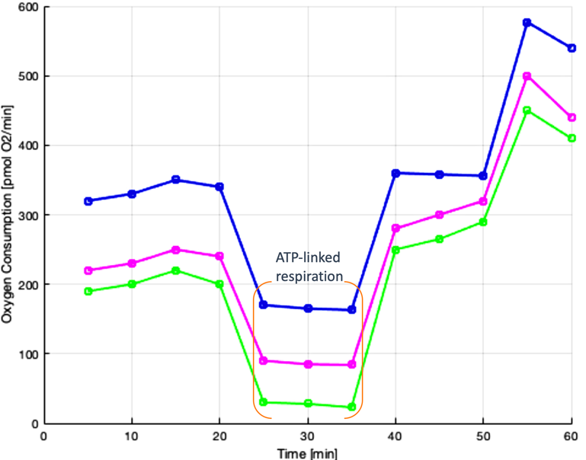

Fig. 1. OCR plot as a function of time for endothelial cell (EC) treated with non-CKD (control) vs. CKD serum or Indoxyl sulfate. Addition of CKD serum and Indoxyl sulfate shows reduced oxygen consumption in the ATP-Linked respiration segment. Low O2 consumption indicates poor mitochondria efficiency.

1. *Assessment of ECAR using Seahorse XFe96 Analyzer.*

B

To examine the effects of uremic metabolites and indoxyl sulfate on endothelial mitochondrial energetics, an assessment of the anaerobic glycolysis process in the mitochondria will be performed. The number of free protons released from the lactic acid that is produced during glycolysis will be measured in the extracellular environment to determine the level of acidity. The higher or lower acidity would give us information on the ECAR in response to the proposed substances.

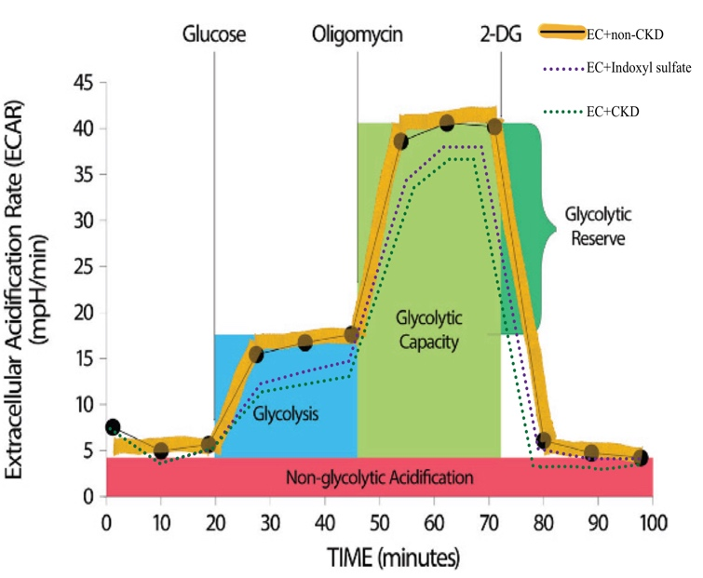

Fig. 2. This figure depicts similar results that we aim examine in our expected results for the ECAR assessment. This graph gives information about the glycolysis process that occurs in the mitochondria. Lower level in the glycolysis segment indicates poor mitochondria efficiency, serving as a key indication of mitochondrial impairment.

1. *Assessment of ROS production using MitoSOX Assay and fluorescence ELISA reader.*

The extent of mitochondria dysfunction will be also assessed through superoxide/ROS production when endothelial cells will be exposed to CKD serum and Indoxyl sulfate. We expect to see an increase in fluorescence intensity for both cases versus the control as shown in Figure 3 and Figure 4. The high intensity means high amounts of superoxide/ROS levels in the endothelial mitochondria. The high levels of ROS will indicate mitochondria impairment, as a result, supporting our hypothesis.

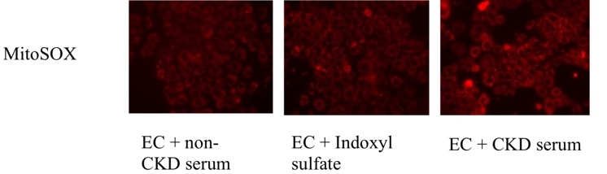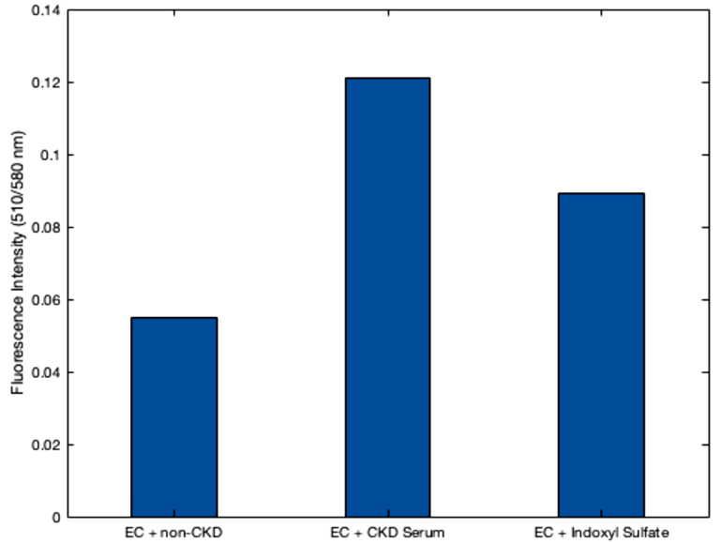

A

Fig. A. MitoSOX assay graph depicting fluorescence intensity values

for endothelial cell (EC) culture exposed to non-CKD serum, CKD serum and Indoxyl sulfate. Fluorescence intensity higher for both uremic metabolite mixture when compared with the control (non-CKD serum). These results indicate high ROS levels in endothelial mitochondria due to large amounts of uremic metabolites. Fig. B. MitoSOX treated endothelial cell (EC) images in the presence of non-CKD serum, CKD serum and indoxyl sulfate. The fluorescence intensities are higher in indoxyl sulfate and slightly higher in CKD serum treated culture. The high intensities indicate high ROS levels in endothelial mitochondria, indicating mitochondria dysfunction.

1. DISCUSSION

High oxidative stress in chronic kidney disease (CKD) patients has shown to cause the progression of cardiovascular disease (CVD) in patients, resulting in premature death [2,4]. Therefore, we aim to understand the underlying causes of CVD in CKD patients suffering from mitochondrial dysfunction. Mitochondrial dysfunction is linked with high oxidative stress in CKD patients due to high uremic toxicity in the body [3]. One research studied mitochondrial content using muscle biopsies obtained from CKD patients and found lower mtDNA copy number and mitochondrial volume comparing with muscle biopsies obtained from healthy patients [9]. Additionally, several other researches have shown altered mitochondrial protein expression, decreased mitochondrial respiratory functions and modified mitochondrial morphology in humans and rodents with CKD [10,11]. Several researches have been conducted to show the negative impacts of uremic metabolites on mitochondria and have pointed out the progression of CVD due to high oxidative stress in CKD patients; however, the molecular mechanisms that spurs the CVD in patients due to mitochondria dysfunction is not well understood. Hence, it becomes imperative to conduct research specifically in line with the progression of CVD in CKD patients to assess mitochondrial energetics under the influence of uremic metabolites.

Currently no research has been conducted that specifically involves the assessment of the oxygen consumption rate (OCR) and extracellular acidification rate (ECAR) when uremic metabolites are exposed to endothelial mitochondria. Similar research although involving different mitochondrial energetics assessment has also been conducted to provide evidence on the negative impacts of uremic metabolites on mitochondria. For example, several uremic metabolites have shown to reduce mitochondrial energy transfer via mitochondrial energy transport system complexes III and IV, and also reduced matrix dehydrogenase, resulting in decreased enzyme activity [3]. Furthermore, this negative interference in mitochondrial enzyme production has shown to induce elevated electron leak, decreased respiratory capacity and OXPHOS conductance in mitochondria [3]. One research has conducted similar MitoSOX based assay to determine mitochondrial ROS level to study skeletal muscle myopathy in CKD patients. Their assays indicated higher mitochondrial-derived oxidative stress via high fluorescence intensity when their cell cultures where exposed to individual uremic toxin vs. control. These are the first few results that sheds light on the mechanism involved in mitochondrial dysfunction due to the accumulation of uremic metabolites in CKD patients.

Upon completion of our proposed experiment, we will potentially have new findings that may help us understand the involvement of CVD in CKD patients through mitochondria dysfunction. The results may help us invent or improve treatments that could potentially prevent premature death of CKD patients due to CVD and be able to receive full treatment for CKD.

ACKNOWLEDGEMENT

Simran Karim thanks Dr. Yan-Ting Shiu, and the Shiu Lab team for their support and assistance in this study.

REFERENCES

1. CDC. “Chronic Kidney Disease in the United States, 2019 Fact Sheet.” *Cdc*, vol. 1, 2019, pp. 1–6, https://www.cdc.gov/kidneydisease/pdf/2019_National-Chronic-Kidney-Disease-Fact-Sheet.pdf.
2. Subbiah, Arun Kumar, et al. “Cardiovascular Disease in Patients with Chronic Kidney Disease: A Neglected Subgroup.” *Heart Asia*, vol. 8, no. 2, 2016, pp. 56–61, doi:10.1136/heartasia-2016-010809.
3. Thome, Trace, et al. “Uremic Metabolites Impair Skeletal Muscle Mitochondrial Energetics through Disruption of the Electron Transport System and Matrix Dehydrogenase Activity.” *American Journal of Physiology - Cell Physiology*, vol. 317, no. 4, 2019, pp. C701–13, doi:10.1152/ajpcell.00098.2019.
4. Fujii, Hideki, et al. “Role of Oxidative Stress and Indoxyl Sulfate in Progression of Cardiovascular Disease in Chronic Kidney Disease.” *Therapeutic Apheresis and Dialysis*, vol. 15, no. 2, 2011, pp. 125–28, doi:10.1111/j.1744-9987.2010.00883.x.
5. Dromparis, Peter, and Evangelos D. Michelakis. “Mitochondria in Vascular Health and Disease.” *Annual Review of Physiology*, vol. 75, 2013, doi:10.1146/annurev-physiol-030212-183804.
6. Hsieh, Hsyue Jen, et al. “Shear-Induced Endothelial Mechanotransduction: The Interplay between Reactive Oxygen Species (ROS) and Nitric Oxide (NO) and the Pathophysiological Implications.” *Journal of Biomedical Science*, vol. 21, no. 1, 2014, pp. 1–15, doi:10.1186/1423-0127-21-3.
7. Gao, Huichang, and Shan Liu. “Role of Uremic Toxin Indoxyl Sulfate in the Progression of Cardiovascular Disease.” *Life Sciences*, vol. 185, no. May, Elsevier, 2017, pp. 23–29, doi:10.1016/j.lfs.2017.07.027.
8. Piroddi, Marta, et al. “Nondialyzable Uremic Toxins.” *Blood Purification*, vol. 35, no. SUPPL.2, 2013, pp. 30–41, doi:10.1159/000350846.
9. Gamboa, Jorge L., et al. “Mitochondrial Dysfunction and Oxidative Stress in Patients with Chronic Kidney Disease.” *Physiological Reports*, vol. 4, no. 9, 2016, pp. 1–12, doi:10.14814/phy2.12780.
10. Avin, Keith G., et al. “Skeletal Muscle Regeneration and Oxidative Stress Are Altered in Chronic Kidney Disease.” *PLoS ONE*, vol. 11, no. 8, 2016, pp. 1–15, doi:10.1371/journal.pone.0159411.
11. Yazdi, Puya G., et al. “Skeletal Muscle Mitochondrial Depletion and Dysfunction in Chronic Kidney Disease.” *International Journal of Clinical and Experimental Medicine*, vol. 6, no. 7, 2013, pp. 532–39.